**Global Communication Ecosystem Development Report (2024) released, experts gathered to discuss international communication theory research and practical innovation**

Source: China Social Sciences Network

Author: Wang Cuncun

Editor: Zhang Sai

2025-04-27

<https://www.cssn.cn/xwcbx/xwcbx_cmkx/202504/t20250427_5871265.shtml>

**China Social Sciences Network** (Reporter Wang Cuncun) On April 23, the 30th "World Book Day", the "Global Communication Ecology Development Report (2024)" was released in Beijing. More than 40 well-known experts and scholars in the field of international communication from universities and research institutes attended the meeting to analyze and look forward to new changes and trends in the global communication landscape, and jointly discuss ways to strengthen the organic combination of international communication theory research and practical innovation.

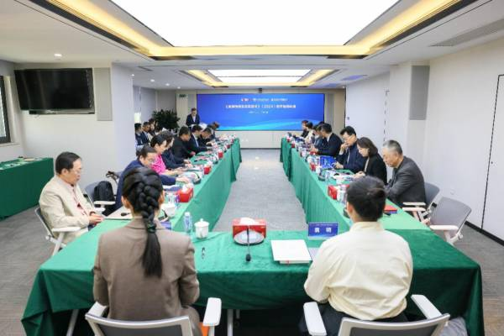

Conference site. Photo provided by the organizer

　　Cui Weihang, Party Secretary of the University of Chinese Academy of Social Sciences, said in his speech that the Global Communication Ecology Blue Book innovatively observes global communication from the perspective of media ecology, providing theoretical support and decision-making reference for building a more effective international communication system. The study of "global communication ecology" has become a consensus across academia and industry. "Putting China's international communication in the context of global communication ecology and building a new era of China's international communication system based on global communication ecology" has become an important trend. It is hoped that the Blue Book will continue to gather the wisdom and strength of senior experts in the field of international communication from academia and industry, and make greater contributions to promoting the reconstruction of the international communication pattern and comprehensively improving the effectiveness of international communication.

　　Ji Xiangde, President of the Social Sciences Academic Press, said in his speech that the Global Communication Ecology Blue Book helps us better understand the evolution of the global communication pattern, grasp the initiative of international communication, and promote the development of communication disciplines. It also provides theoretical support and practical guidance for international communication practice, helping to improve my country's international communication effectiveness and enhance international discourse power. Through in-depth research on the global communication ecology, we can better respond to international public opinion challenges, shape the national image, and promote cultural exchanges and mutual learning between China and foreign countries.

　　Gao Wei, chairman of Global International Video Communications Agency Co., Ltd. and editor-in-chief of the Global Communication Ecology Blue Book, said that the research and publication of this blue book is an important achievement of the industry working together with academia to integrate theory with practice. He expects the blue book to continue to make greater contributions to promoting theoretical research and practical innovation in international communication and to building a more effective international communication system.

　　Jiang Fei, Vice President of the University of Chinese Academy of Social Sciences and Chief Editor of the Global Communication Ecology Blue Book, delivered a keynote speech. He analyzed the characteristics of the current global communication ecology and put forward three forward-looking tips: First, the information infrastructure ecology of global communication has undergone structural changes, which has led to the continuous increase in the rate of information flow and information appreciation/depreciation; second, privacy and security issues have frequently emerged in the process of rapid global digitalization, and AI-based digital fraud needs to be dealt with urgently; third, on the premise of a deep understanding of the complexity of international communication, we should promote the improvement of the artistry and strategy of China's international communication to serve the construction of China's independent knowledge system for international communication in the new era.

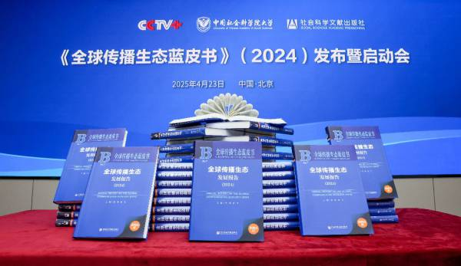

Photo of the Blue Book. Photo provided by the organizer

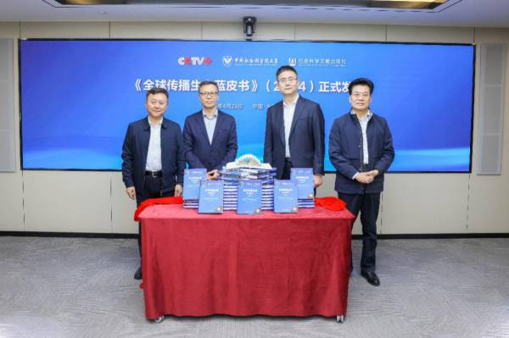

Scholars present at the conference unveiled the new book. Photo provided by the organizer

　　Shi Anbin, Party Secretary of the School of Journalism and Communication at Tsinghua University, believes that, in general, the future direction of international communication is to be guided by the Marxist view of journalism and strengthen AI empowerment. Focus on two shifts, one is the "Southern Turn" and the other is the "interpersonal turn". Do three things well: first, jointly build a community of common prosperity of global civilizations, promote global civilization dialogue and emotional integration between different civilizations; second, create a digital and intelligent communication matrix to promote Chinese culture overseas; third, lead global digital governance, win more discourse power, guide AI for good, and ensure that southern countries are no longer "absent" or "speechless".

　　Lu Di, associate professor at the New Media Research Institute of Communication University of China, believes that intelligent entities will reconstruct the omnimedia communication system. The trend of "de-APPization" is irresistible, and new "entry-type" platforms may emerge. Intelligent entities enable the media to transform from "content producers" to "intelligent service providers", build a multi-party intelligent communication ecosystem, and transform communication capabilities into lightweight, scenario-based service units to achieve precise reach, providing huge opportunities for international communication.

　　Wang Qing, dean of the School of Language and Communication at Beijing University of Technology, said that international communication in the economic field, such as the construction of China's economic external communication discourse system and effectiveness evaluation, China's discourse construction strategy in the global digital trade rules game, and new scenarios in international communication, such as international communication research under the perspective of algorithmic cognitive warfare, and multimodal symbolic coordination of social media texts, images, and data, are also important directions and dimensions of international communication theory research.

　　Li Yu, director of the Overseas Evaluation and Verification Division of the International Communication Planning Bureau of China Media Group, said that due to factors such as declining income, squeezed by the market and commercial media, and changes in media usage, the overall development situation of global public media has become increasingly severe. Faced with challenges such as industry evolution and ecological changes, US media hegemony and market monopoly, media system and government policies, and information disorder and distortion, public media should strengthen their public service advantages and continuously improve their operating conditions and adaptability.

　　During the seminar, experts and scholars held a lively and in-depth discussion on new changes and trends in the global communication ecology.

　　The conference was co-organized by Global International Video Communications Agency Co., Ltd., University of Chinese Academy of Social Sciences, and Social Sciences Academic Press.